**Promoting Skating Board School with a Modern AWS S3-Hosted Website**

**Problem Statement:**

A Skating Board school aims to promote its services and reach a wider audience by establishing an online presence. The school faces the challenge of effectively showcasing its offerings, upcoming events, and contact information to attract potential students and partners. To address this, the school seeks to implement a modern and user-friendly website using AWS S3 for web hosting. This website will serve as a promotional platform, providing detailed information about the school's programs, events, and a dedicated contact section for inquiries. The project aims to enhance the school's visibility, engage with prospective students, and streamline communication through a professional online platform.

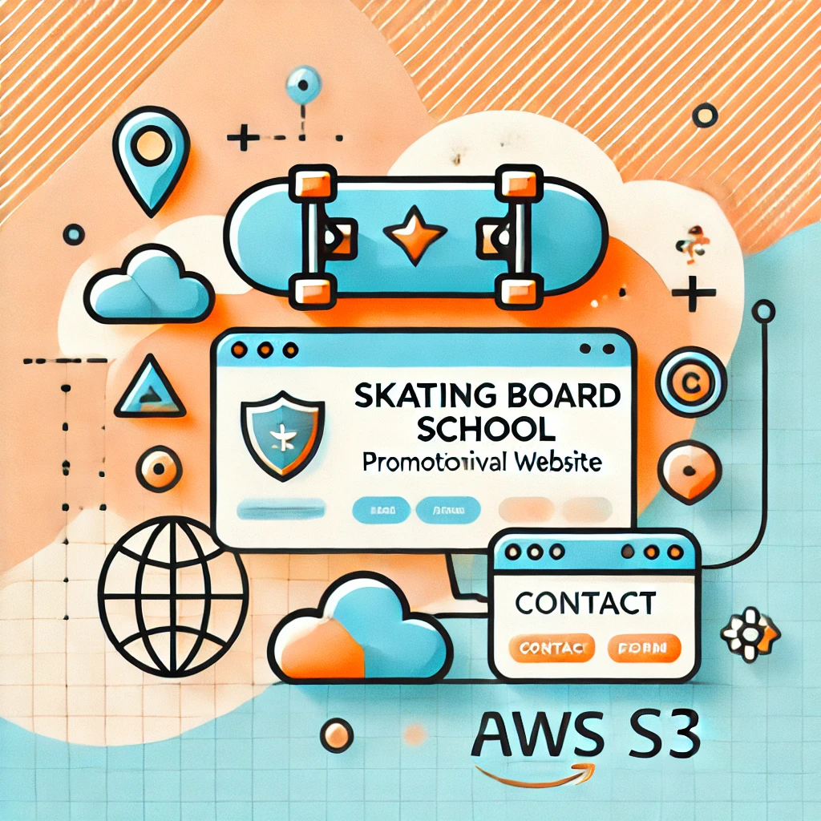

**Pre-requisites:**

### 1. AWS Account Setup: [https://youtu.be/CjKhQoYeR4Q?si=ui8Bvk_M4FfVM-D](https://youtu.be/CjKhQoYeR4Q?si=ui8Bvk_M4FfVM-Dh)h

### 2. Understanding of IAM: <https://youtu.be/gsgdAyGhV0o?si=3qg-bULgkD4LXNvR>

### 3. Basic Knowledge of Amazon S3: <https://youtu.be/bktTomENEX8?si=dsJImPcPJrZY50CE>

**Objective:**

The primary objective of this project is to create a promotional website for the Skating Board school using AWS S3 for web hosting. The website aims to enhance the school’s online presence, attract potential students, and provide essential information about its programs and events. Additionally, the website will feature a contact section to facilitate easy communication between the school and prospective students or partners. By leveraging AWS S3, the project ensures a secure, scalable, and efficient platform to promote the school and engage with the wider community.

**Tasks:**

1. Login to AWS Management Console
2. Create an S3 Bucket
3. Upload Website Files
4. Configure Static Website Hosting
5. Set Up Bucket Permissions
6. Access the Website URL

**Solution Development Procedure:**

1. Log in to the AWS Management Console and navigate to the S3 service.

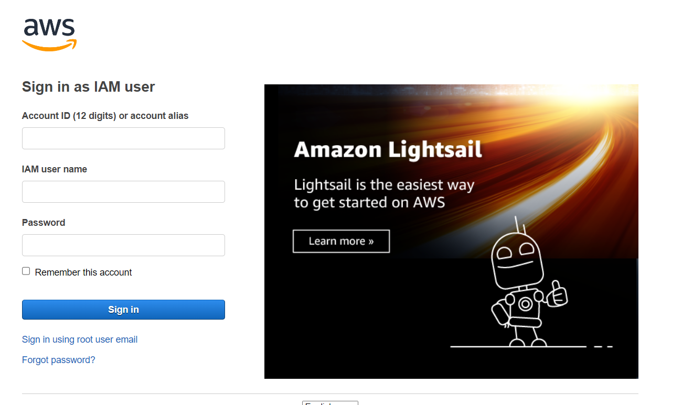

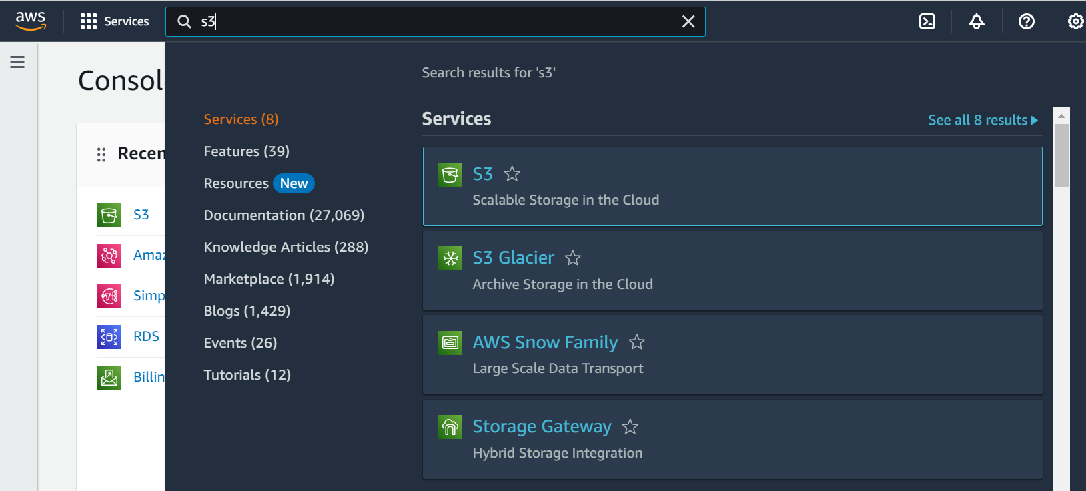

1. Create an S3 bucket

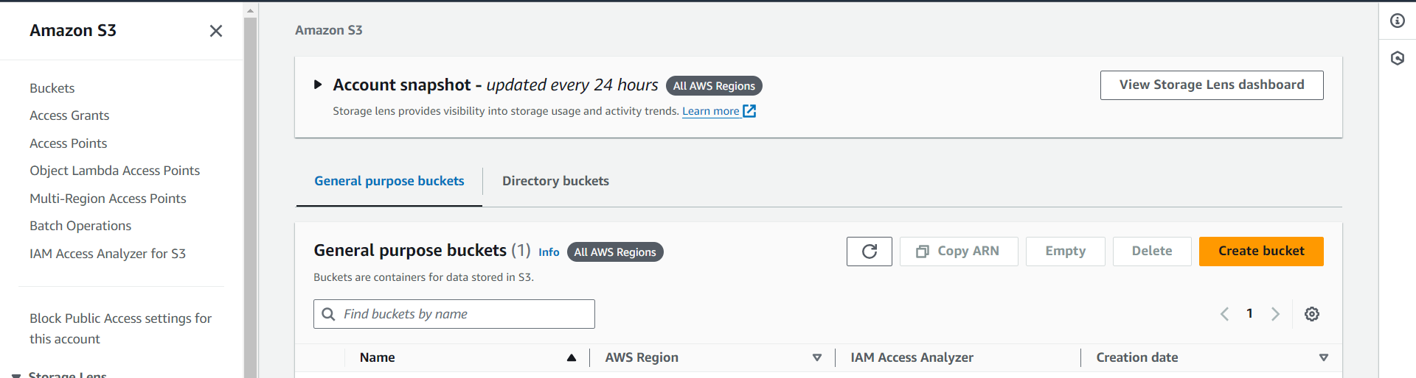

* Click on Create bucket Button to create an bucket

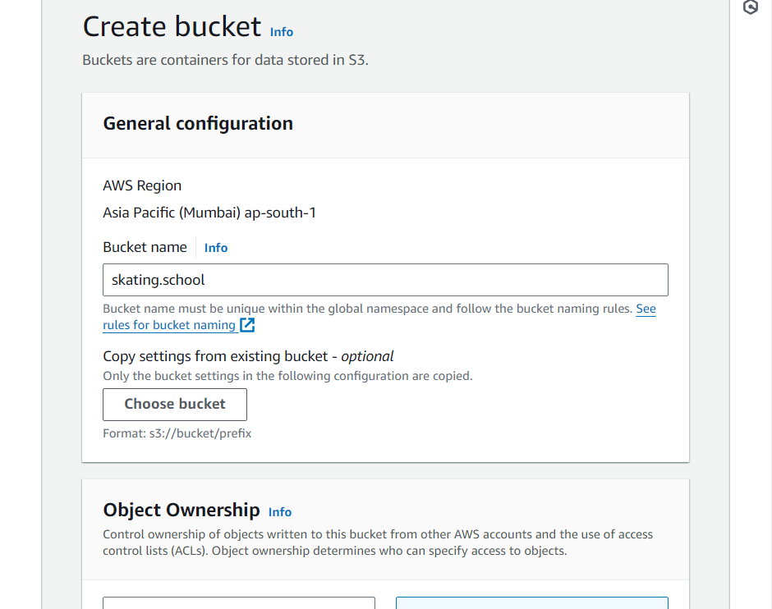

* Enter Bucket Name.

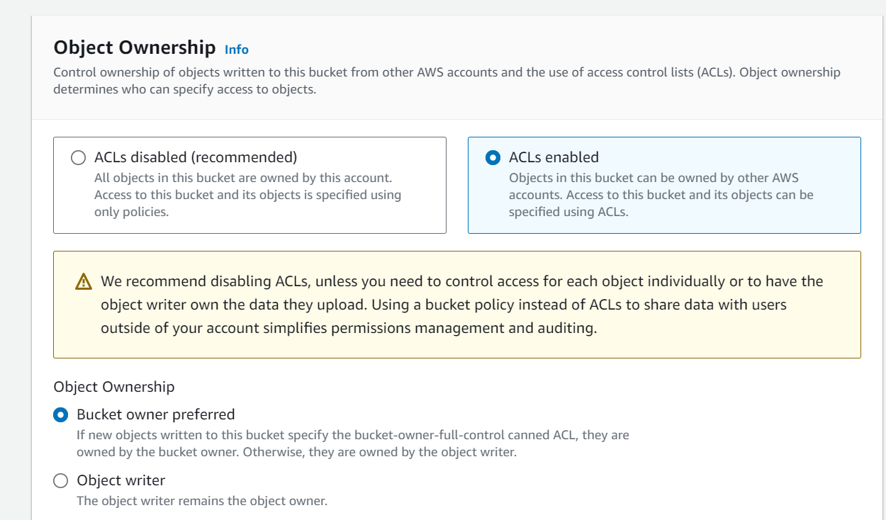

* Enable ACLs Ownership

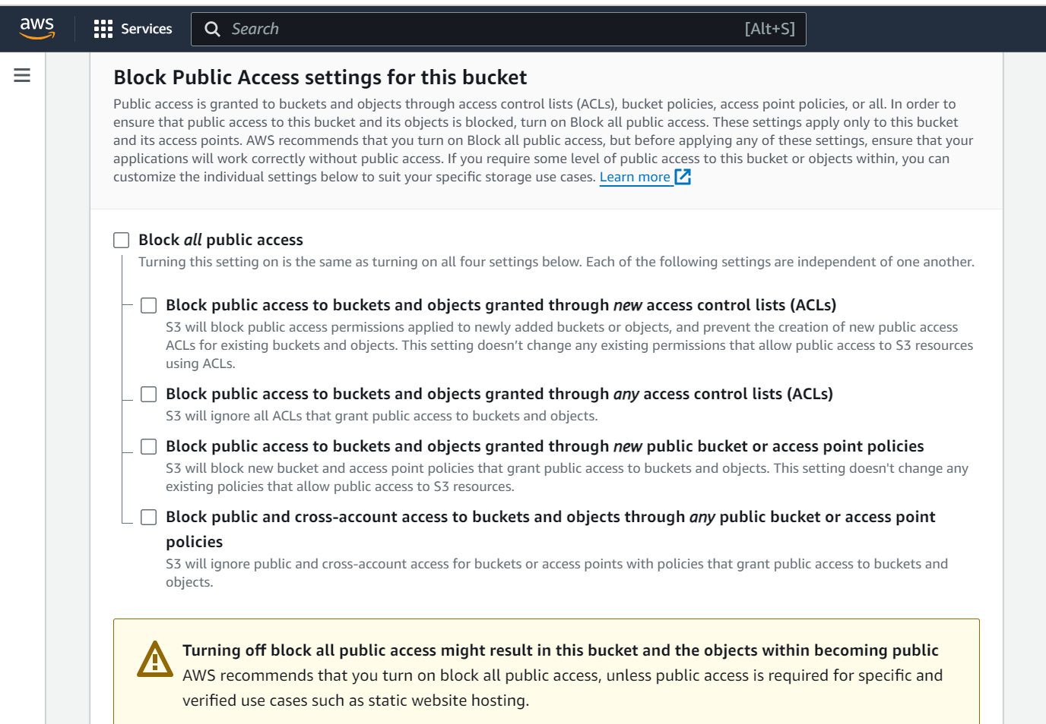

* Unclick on Block all public access.

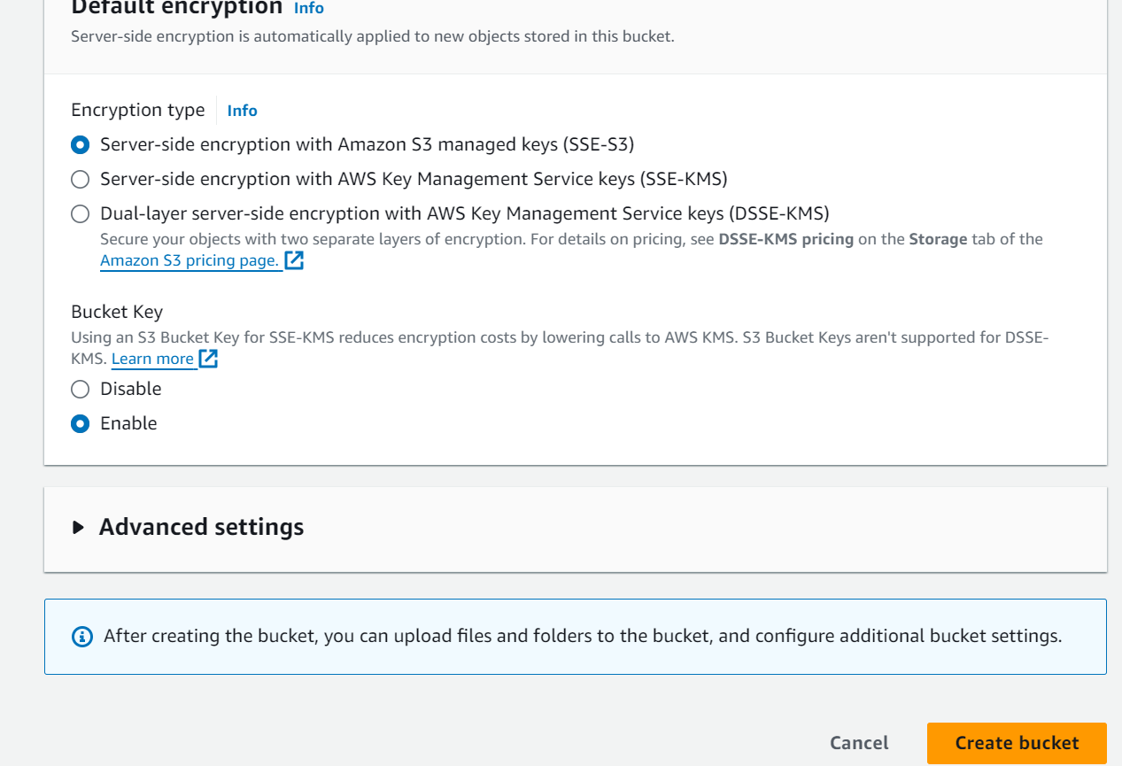

* Click on Create bucket.

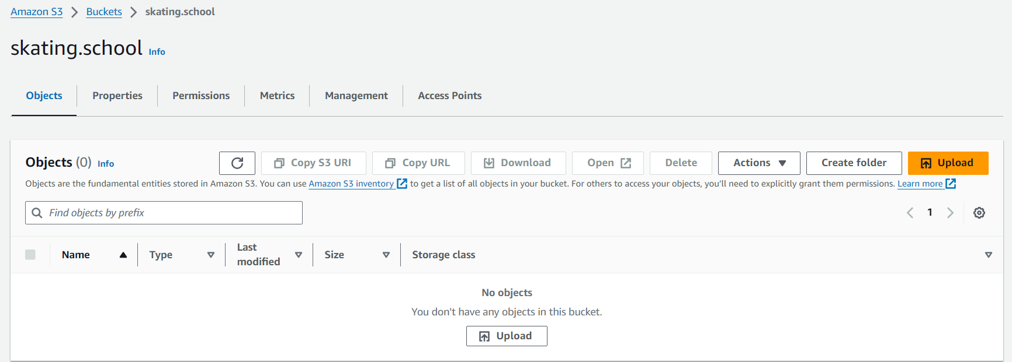

* The Bucket with skating.school successfully created now click on the Upload Button to upload the folder files.

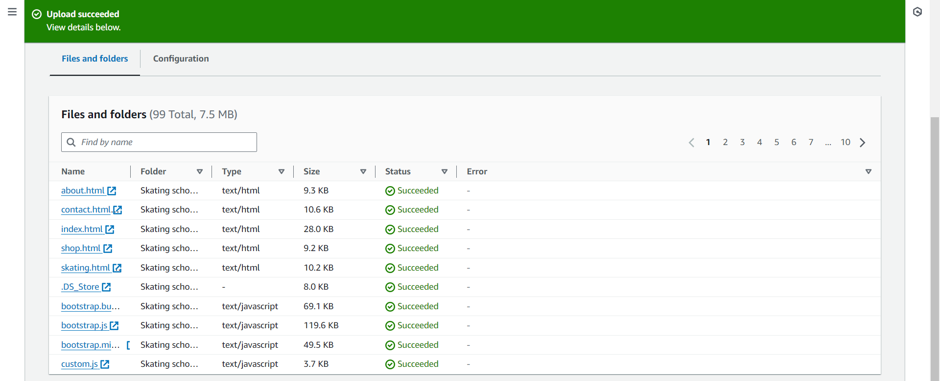

* The files of the folder , successfully loaded.

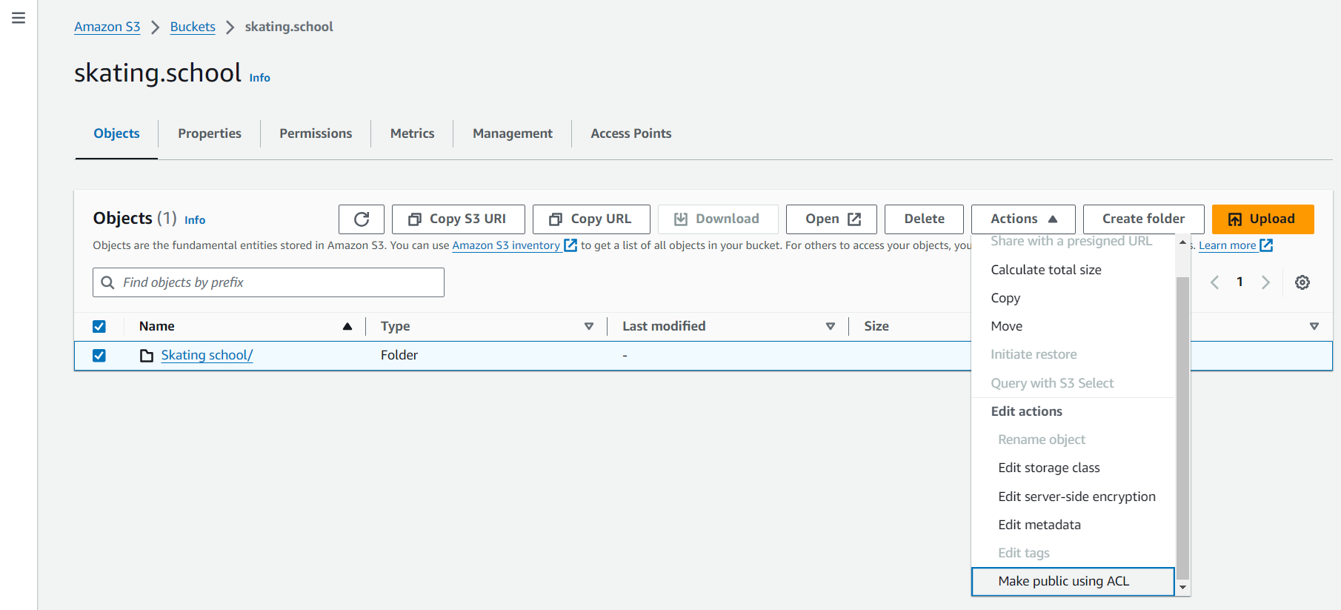

* Now select the folder and click on Actions and Choose ‘Make public using ACL’

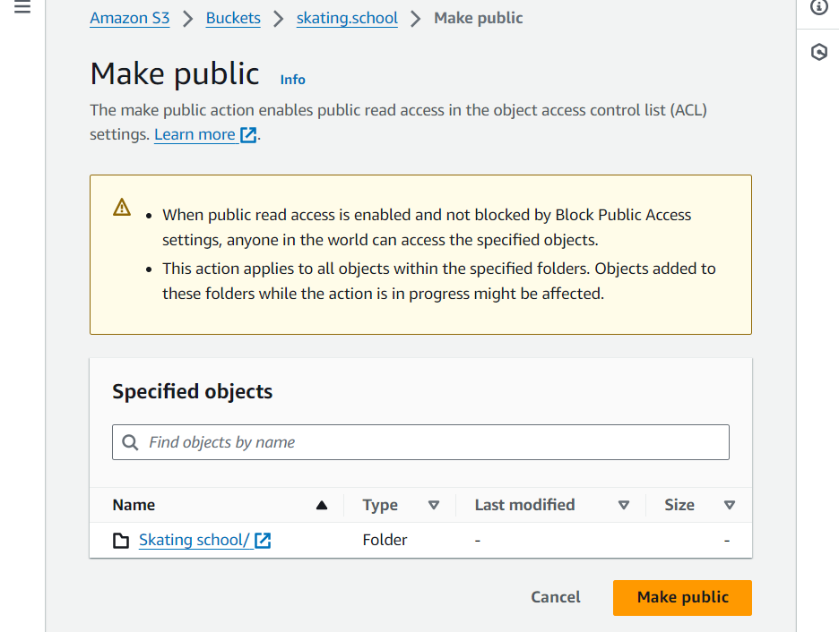

* Click on Make public

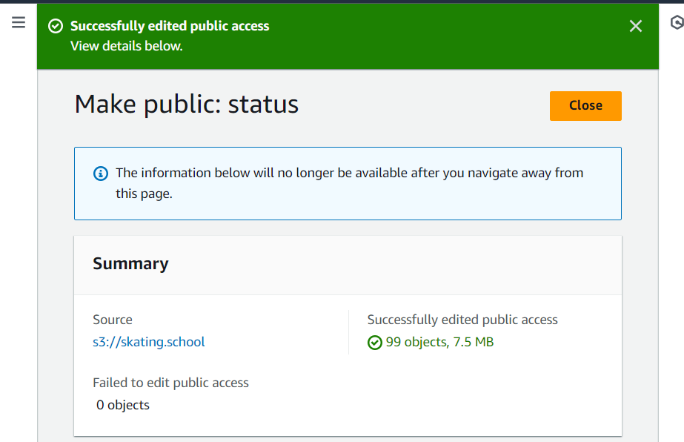

1. Configure Static Website Hosting

* Go to properties > Scroll down > Click on Edit > enter the main page name and done

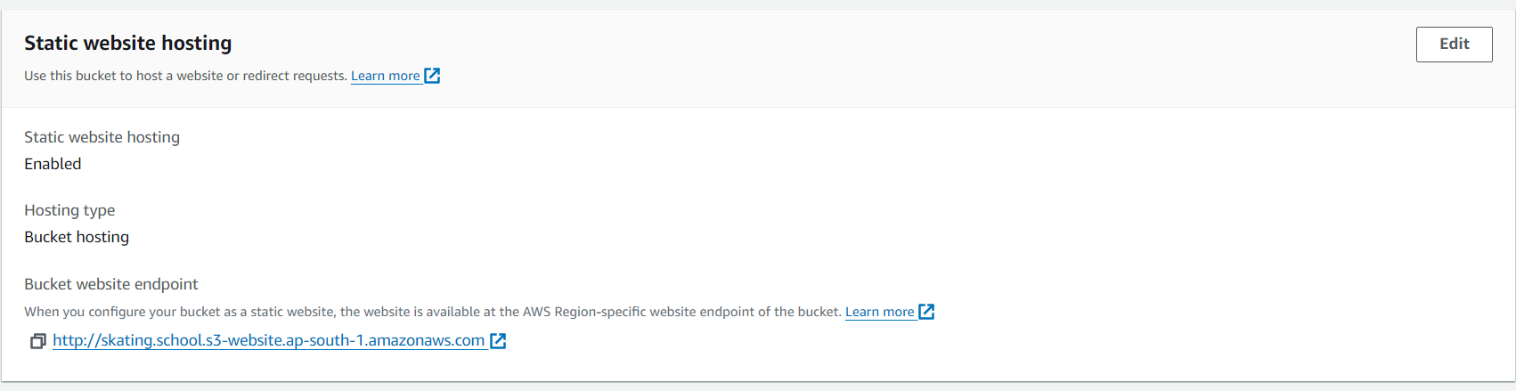

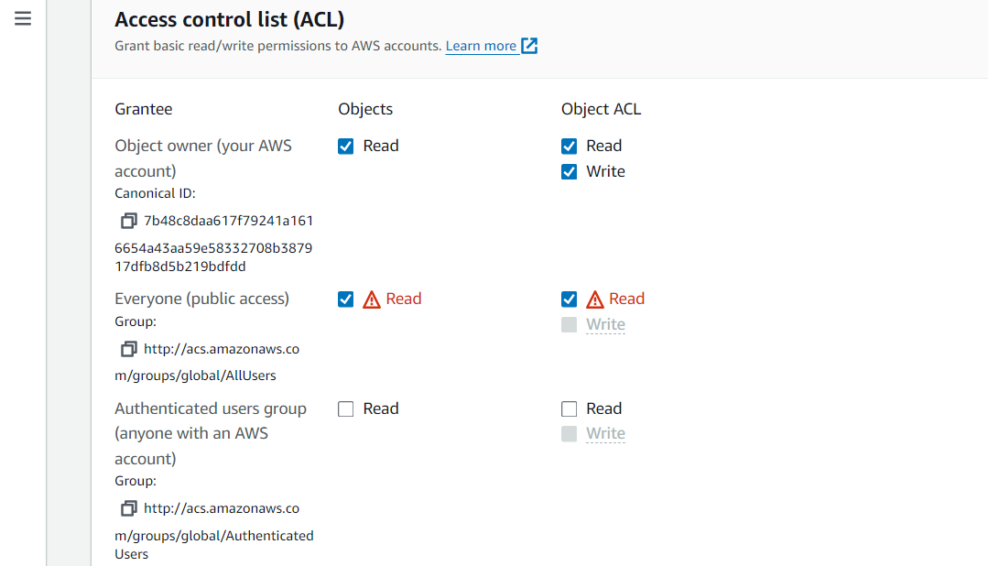

* Make sure that Read access is given to everyone in public access

1. Setting up Bucket Permissions

* Now go to Permissions > Bucket Policy > Edit > Enter the below code and mention your bucket name clearly.

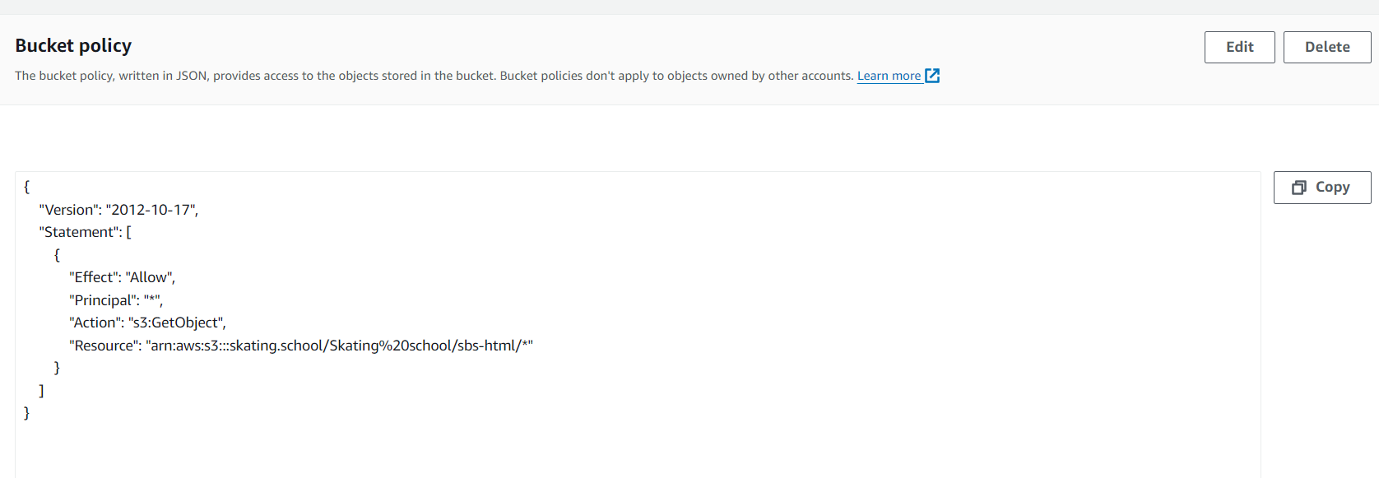

1. Accessing the web Page

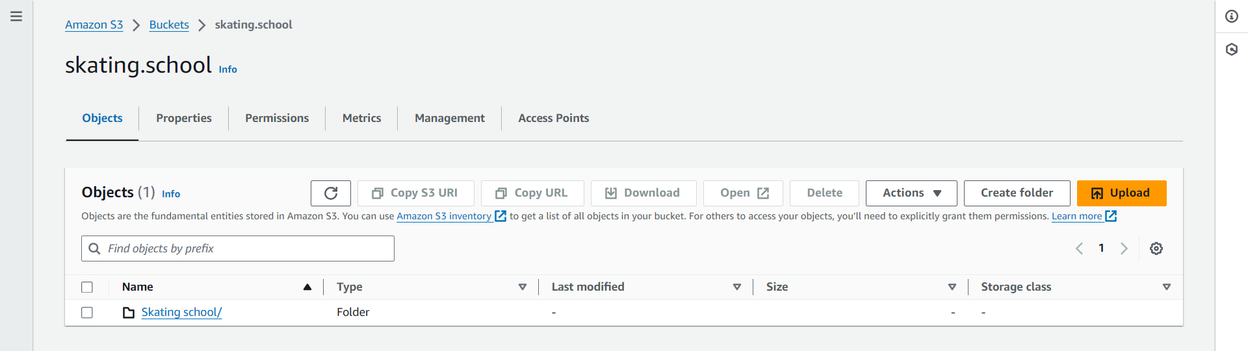

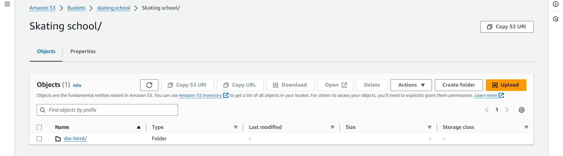

* Go to the bucket and select the file folders to navigate into the files.
* 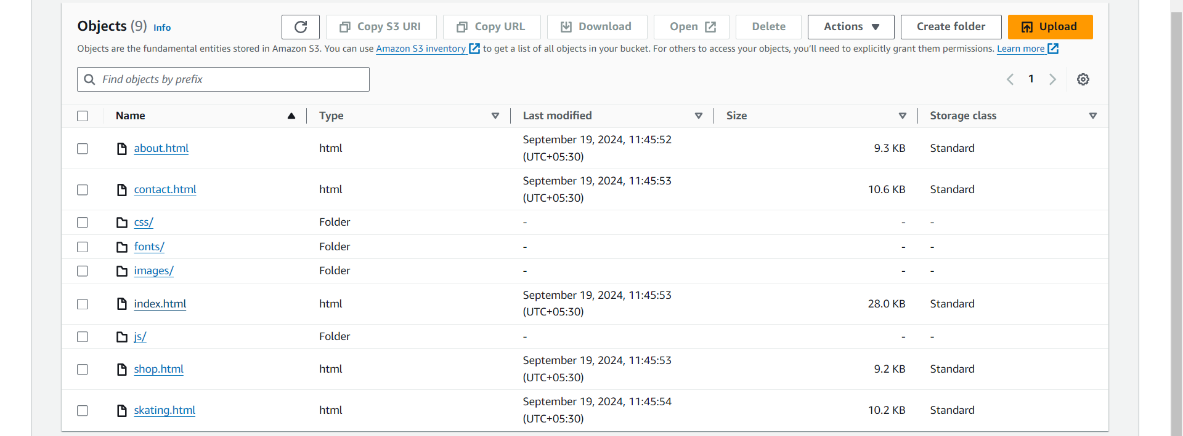
* Now select the hosting file and click on it, here index.html

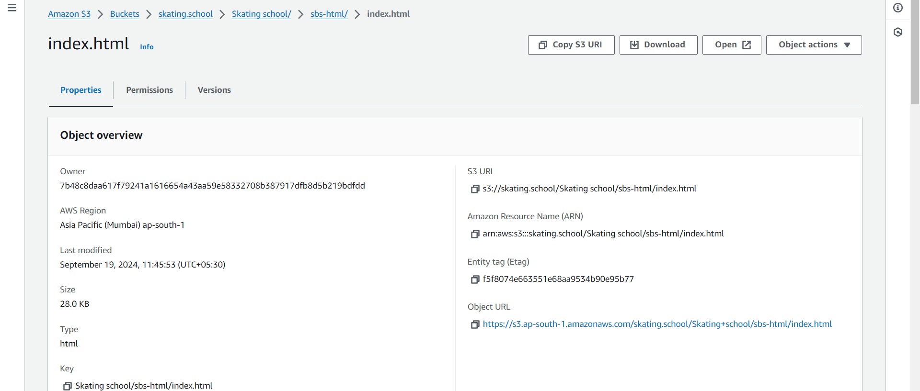

* Follow the Object URL , to open the website

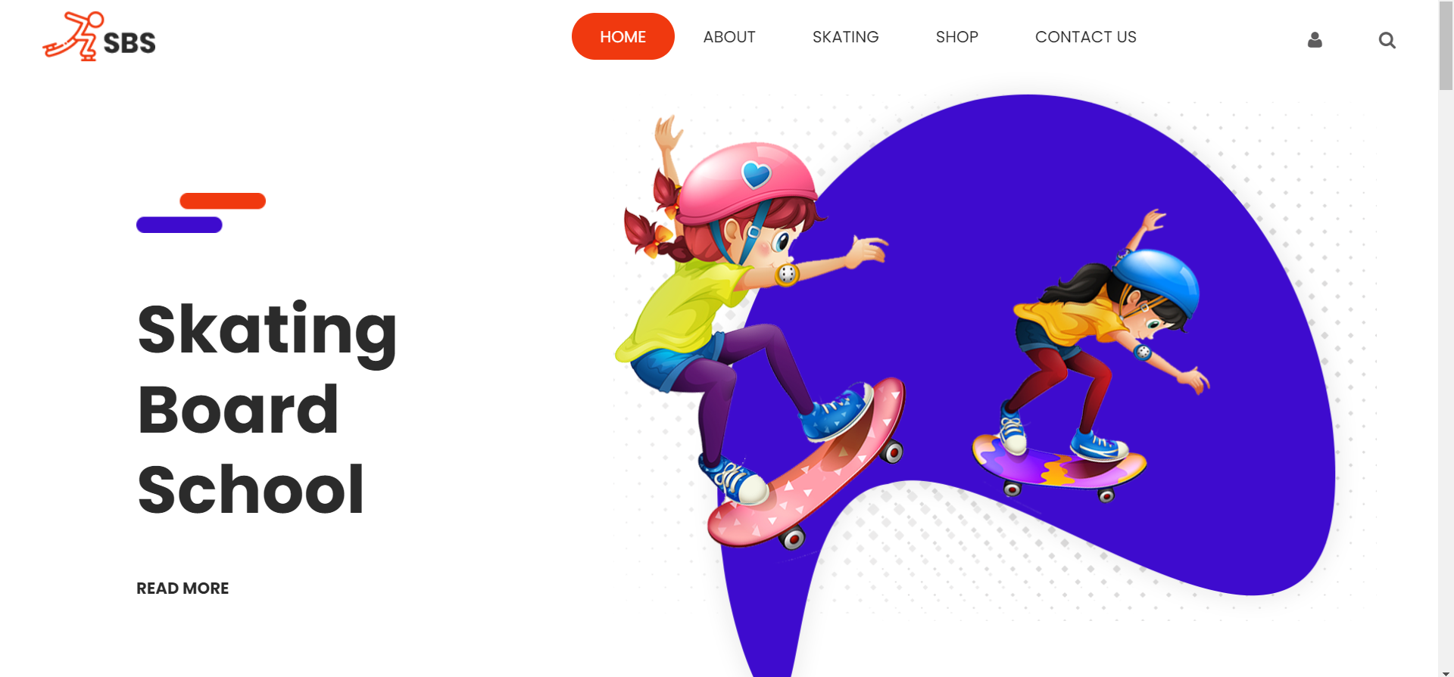

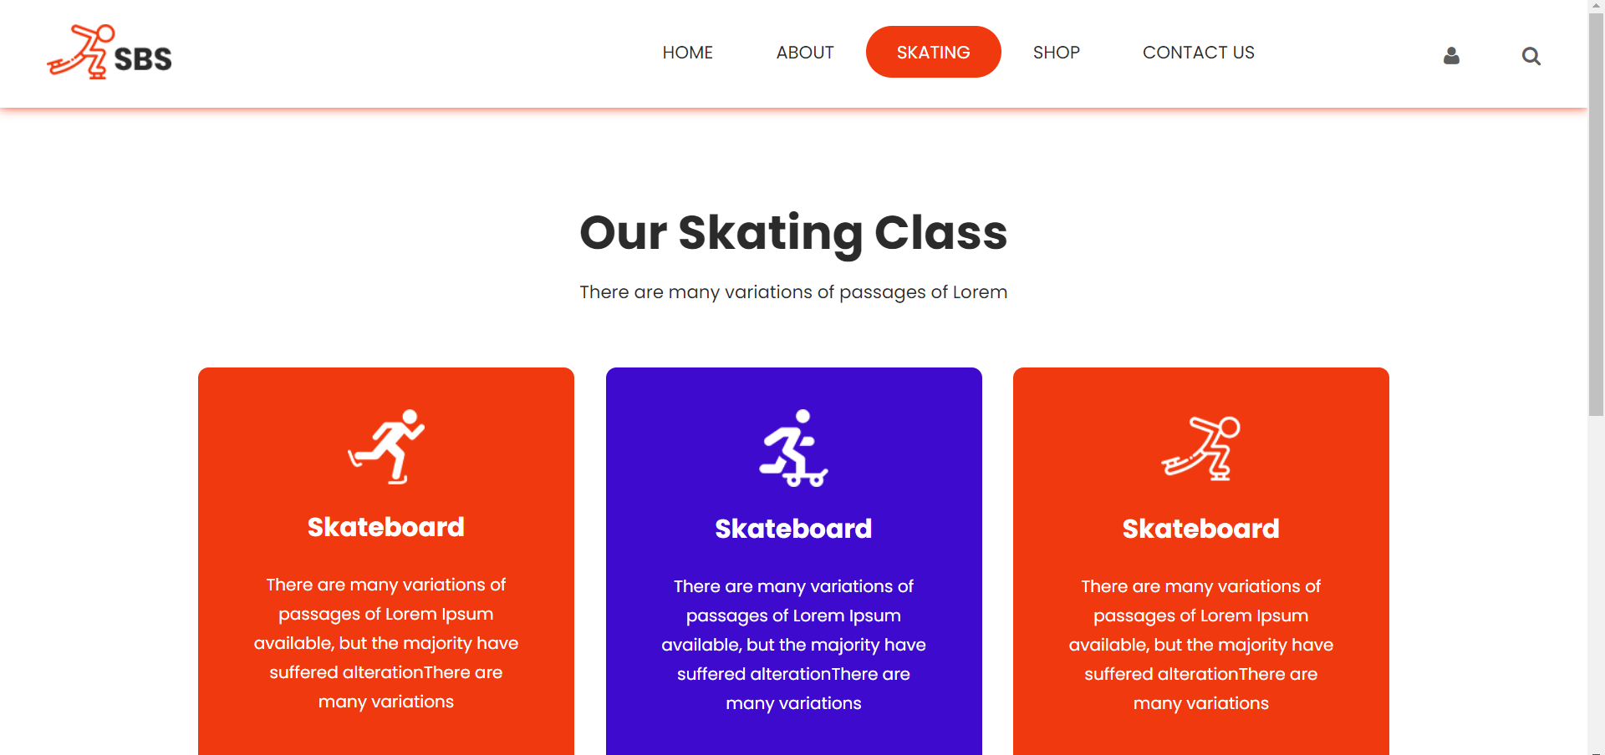

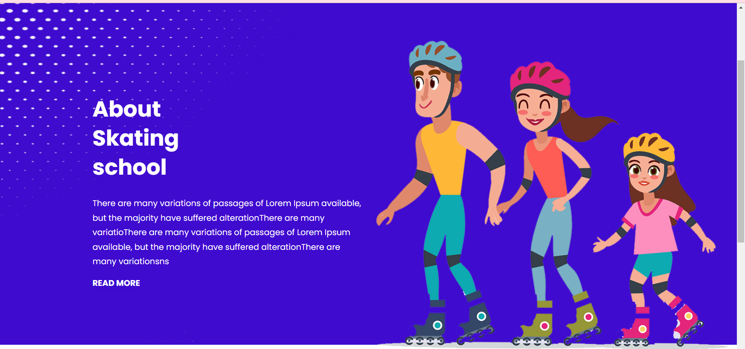

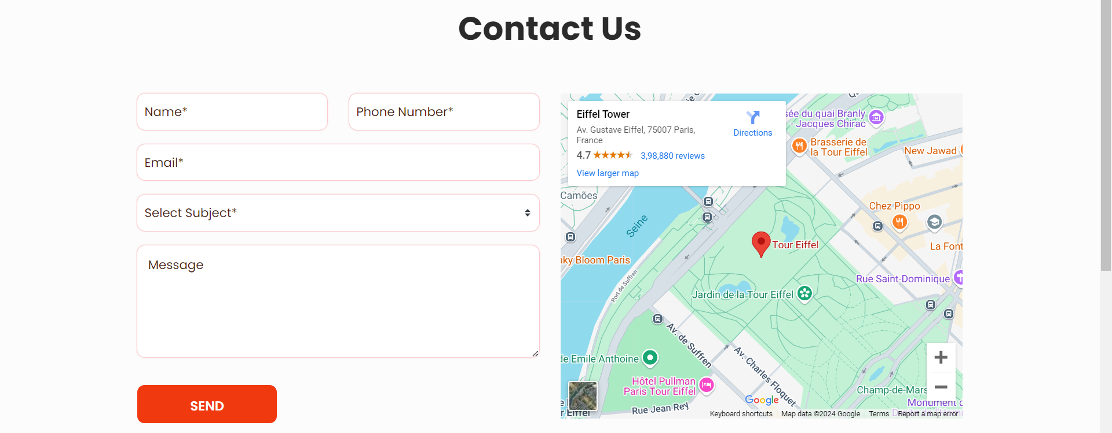

**Conclusion:**

By implementing a promotional website for the Skating Board school using AWS S3, the project successfully enhances the school’s visibility and reach. The website provides a user-friendly platform to showcase the school's programs and events while offering a dedicated contact section for easy communication. Hosting the site on AWS S3 ensures secure and scalable web infrastructure, supporting the school’s goals to promote its offerings and engage with potential students and partners. This project strengthens the school’s online presence, helping it grow and connect with the community more effectively.